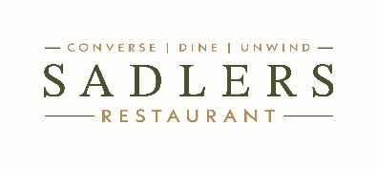

Set Menu

Two Courses – £18.95
Three Courses – £24.95

Starters

Wye Valley Asparagus, Dorset crab, sourdough

Pickled celeriac, chilli, baked ricotta (V, GF)

Pork collar, anchovy mayonnaise, capers (GF)

Mains

Fried gnocchi, wild garlic pesto, burrata (V, GF)

Chalk stream trout, pink fir potatoes, Somerset cider sauce (GF)

Guinea fowl, pot roast savoy cabbage, peppercorn jus (GF)

Desserts

Dark chocolate cremeux, olive oil, sea salt (VG*, GF)

Baked apples, almond streusel, vanilla ice cream (V)

Saffron poached pear, honey, whipped mascarpone (VG*, GF)

V · Vegetarian VG · Vegan VG* · Vegan Option Available GF · Gluten Free
Please inform a member of our team of any allergies or dietary requirements before ordering

