
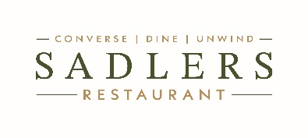

Set Menu

Two Courses – £18.95
Three Courses – £24.95

Starters

Pan con tomate, Dorset crab, confit garlic (GF*)

Pickled celeriac, chilli, baked ricotta (V, GF)

Pork collar, anchovy mayonnaise, capers (GF)

Mains

Fried gnocchi, tomato sauce, basil, burrata (V, GF*)

Chalk-stream trout, white beans, cucumber, tomato butter (GF)

Roasted corn-fed chicken breast, pepperonata, almonds (GF)

Desserts

Dark chocolate cremeux, olive oil, sea salt (VG*, GF)

Baked apples, almond streusel, vanilla ice cream (V)

Saffron poached pear, honey, whipped mascarpone (VG*, GF)

V · Vegetarian VG · Vegan VG* · Vegan Option Available GF · Gluten Free
Please inform a member of our team of any allergies or dietary requirements before ordering

